# **Ubuntu Server vs. Red Hat vs. CentOS**

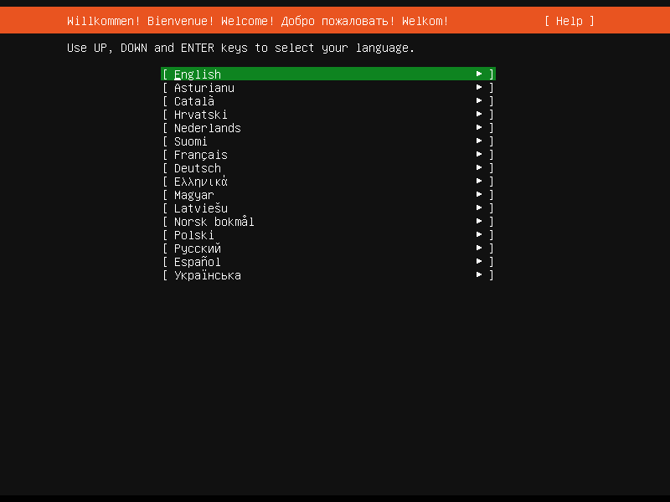

When it comes to server operating systems, there’s no shortage of options. Among the many, three often stand out: Ubuntu Server, Red Hat Enterprise Linux (RHEL), and CentOS. Each of these has its strengths, weaknesses, and ideal use cases. However, before we dive into the comparison, let’s take a brief trip down memory lane to understand the roots of these systems in the form of Unix.

**The Roots: A Brief History of Unix**

Unix, a powerful, multitasking, multi-user operating system, was developed in the 1970s at the Bell Labs research center. Unix’s inception was more than just the birth of another operating system; it set the stage for a new wave of computing and influenced numerous systems that followed. A pivotal element of Unix is its principle of keeping things simple — a concept that would carry forward into many of its derivatives, collectively termed as Unix-like or Unix-based systems, which include the likes of Linux and BSD.

**The Contenders: Ubuntu Server, RHEL, and CentOS**

Now, let’s turn our attention to the three key players at hand. While they are all built upon the principles set by Unix, they have taken their unique paths.

**Ubuntu Server**

Ubuntu Server is an open-source platform that effortlessly scales along with your operations. With its predictable release cycle (every two years), it is widely recognized for its stability and user-friendly approach. The operating system stands out with its robust built-in security, wide hardware compatibility, and extensive package repositories.

**Red Hat Enterprise Linux (RHEL)**

RHEL is a commercial product from Red Hat Inc., bringing along a suite of support and services not available in free-to-use platforms. It is favored for its exceptional enterprise-level support, strong emphasis on stability and security, and extensive training and documentation. A notable downside, however, is its licensing cost, which might deter smaller projects and organizations.

**CentOS**

CentOS, standing for Community Enterprise Operating System, is essentially a free version of RHEL. It mirrors the stability and features of RHEL without the cost of licenses and support. This makes it an attractive choice for users who want enterprise-level capabilities without heavy expenses. However, the project’s future became uncertain when Red Hat announced a shift in focus towards CentOS Stream, which will serve as an upstream (development) branch for RHEL.

Other Notable Distributions

Apart from these three, several other distributions warrant a mention:

**Debian:** Known for its strict adherence to open-source principles, Debian is famous for its stability and reliability.

**Fedora:** Sponsored by Red Hat, Fedora serves as a testing ground for new features, many of which may eventually make their way into RHEL.

**openSUSE:** With its easy-to-use setup and configuration tools,openSUSE is a strong contender for both desktops and servers.

Comparison Chart

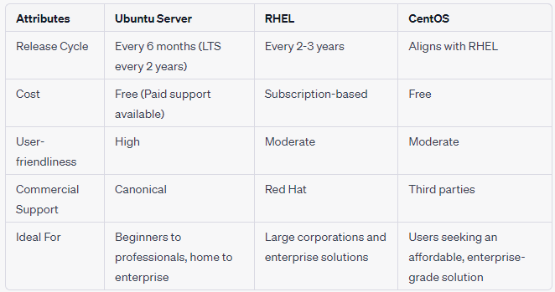

**Conclusion**

The choice between Ubuntu Server, Red Hat, and CentOS comes down to your specific needs and circumstances. If your organization requires enterprise-level support and stability, and budget isn’t a primary concern, Red Hat Enterprise Linux would be an ideal choice. On the other hand, if you’re keen to learn and explore, and you’re in a home or small-scale environment where enterprise-level support isn’t crucial, Ubuntu Server or CentOS could be a good starting point. Ultimately, the best operating system is the one that aligns most closely with your requirements and comfort level.